**MATH**

**Unit 1.**Colors, Shapes and patterns

**Unit 2.**Sizes (Big and Small)

**Unit3.** Positions (Up and down, Left and right, Over and Under)

Unit 4. Sets ( empty and full)

**Unit5.**Numerals no.1-5

**Science**

**Unit 1.** Parts of the body,Sense Organs(eyes,nose,ears,hand,tounge) Taste of foods

**Unit 2.** Plants (Flowers, Vegetables, fruits, proper care of plants)

**Unit 3.** Animals ( Animals in rivers and sea, animals in land, animals in air)

**Unit 4.** Things around us ( Source of water , the light, kinds of weather)

Kuya crush, eto po ung mga exercises per unit and subject..registration, delete, update, and if makaya muh kuya crush yung pag appear ng kanyang progress. Example is kunwari..after nia na natapos ung mga exercises mag appear ung kanyang result.

**English**

Letters from A- Z

Objectives:

1. Provide a system that can register, update and delete, a pupils information.
2. Provide a system that can consolidate the exercises of the pupils online.
3. Provide a system that enables the pupils to answer and accomplish exercises online.
4. Provide a website that can access the interactive learning system.
5. Summarize the pupil progress.



<HTML>

<HEAD>

<TITLE>Math</TITLE>

<META HTTP-EQUIV="Content-Type" CONTENT="text/html; charset=iso-8859-1">

<style title="cssmenu">

import url(http://fonts.googleapis.com/css?family=Lato:300,400,700);

@charset 'UTF-8';

/* Base Styles */

#cssmenu > ul,

#cssmenu > ul li,

#cssmenu > ul ul {

list-style: none;

margin: 0;

padding: 0;

}

#cssmenu > ul {

position: relative;

z-index: 597;

float: left;

}

#cssmenu > ul li {

float: left;

min-height: 1px;

line-height: 1.3em;

vertical-align: middle;

padding: 10px;

}

#cssmenu > ul li.hover,

#cssmenu > ul li:hover {

z-index: 599;

cursor: default;

}

#cssmenu > ul ul {

visibility: hidden;

position: absolute;

top: 100%;

left: 0;

z-index: 598;

}

#cssmenu > ul ul li {

float: none;

}

#cssmenu > ul li:hover > ul {

visibility: visible;

}

/* Align last drop down RTL */

/* Theme Styles */

#cssmenu > ul a:link {

text-decoration: none;

}

#cssmenu > ul a:active {

color:#FFFF99;

}

#cssmenu li {

padding: 0;

color:#CCFFCC;

}

#cssmenu {

font-family:"comic sans ms",bold;

color:#0000FF;

width:auto;

-webkit-border-radius: 3px;

-moz-border-radius: 3px;

-ms-border-radius: 3px;

-o-border-radius: 3px;

border-radius: 3px;

background:#FF00CC;

font-size: 20px;

-moz-box-shadow: inset 0 2px 2px rgba(255, 255, 255, 0.3);

-webkit-box-shadow: inset 0 2px 2px rgba(255, 255, 255, 0.3);

box-shadow: inset 0 2px 2px rgba(255, 255, 255, 0.3);

}

#cssmenu > ul {

padding: 0 5px;

-moz-box-shadow: inset 0 -2px 2px rgba(0, 0, 0, 0.3);

-webkit-box-shadow: inset 0 -2px 2px rgba(0, 0, 0, 0.3);

box-shadow: inset 0 -2px 2px rgba(0, 0, 0, 0.3);

-webkit-border-radius: 3px;

-moz-border-radius: 3px;

-ms-border-radius: 3px;

-o-border-radius: 3px;

border-radius: 3px;

display: block;

float: none;

zoom: 1;

font-size:24px;

}

#cssmenu > ul:before {

content: '';

display: block;

}

#cssmenu > ul:after {

content: '';

display: table;

clear: both;

}

#cssmenu > ul > li {

padding: 8px 5px;

}

#cssmenu > ul > li > a,

#cssmenu > ul > li > a:link,

#cssmenu > ul > li > a:visited {

text-shadow: 0 -1px 1px #004881;

color:#FFFF99;

padding: 7px 20px;

display: block;

-webkit-border-radius: 3px;

-moz-border-radius: 3px;

-ms-border-radius: 3px;

-o-border-radius: 3px;

border-radius: 3px;

}

#cssmenu > ul > li > a:hover,

#cssmenu > ul > li:hover > a {

background-color: #0082e7;

}

#cssmenu li li a {

color:#0000FF;

font-size: 18px;

}

#cssmenu li li a:hover {

color:#FF00FF;

border-color: #5c5c5c;

}

#cssmenu ul ul {

margin: 0 10px;

padding: 0 10px;

float: none;

background:#00CC00;

border: 2px solid #1b9bff;

border-top: none;

right: 0;

left: 0;

-webkit-border-radius: 0 0 3px 3px;

-moz-border-radius: 0 0 3px 3px;

-ms-border-radius: 0 0 3px 3px;

-o-border-radius: 0 0 3px 3px;

border-radius: 0 0 3px 3px;

-moz-box-shadow: 0 2px 3px rgba(0, 0, 0, 0.2);

-webkit-box-shadow: 0 2px 3px rgba(0, 0, 0, 0.2);

box-shadow: 0 2px 3px rgba(0, 0, 0, 0.2);

}

#cssmenu ul > li > ul > li {

margin: 0 10px 0 0;

position: relative;

padding: 0;

float: left;

}

#cssmenu ul > li > ul > li > a {

padding: 10px 20px 10px 10px;

display: block;

}

#cssmenu ul > li > ul > li.has-sub > a:before {

content: '';

position: absolute;

top: 18px;

right: 6px;

border: 5px solid transparent;

border-top: 5px solid #8b8b8b;

}

#cssmenu ul > li > ul > li.has-sub > a:hover:before {

border-top: 5px solid #5c5c5c;

}

#cssmenu ul ul ul {

width: 200px;

top: 100%;

border: 2px solid #1b9bff;

}

#cssmenu ul ul ul li {

float: none;

}

</style>

</HEAD>

<center><BODY background="back copy.jpg" LEFTMARGIN=0 TOPMARGIN=0 MARGINWIDTH=0 MARGINHEIGHT=0>

<div align="center"><font color="#FF00FF" ><span id="spanDate"></span></font></div>

<script type="text/javascript">

var months = ['January','February','March','April','May','June','July',

'August','September','October','November','December'];

var tomorrow = new Date();

tomorrow.setTime(tomorrow.getTime() + (1000*3600*24));

document.getElementById("spanDate").innerHTML = months[tomorrow.getMonth()] + " " + tomorrow.getDate()+ ", " + tomorrow.getFullYear();

</script>

<!-- ImageReady Slices (Math.psd) -->

<TABLE WIDTH=1000 BORDER=0 CELLPADDING=0 CELLSPACING=0>

<TR>

<TD COLSPAN=5>

<IMG SRC="images/Math_01.jpg" WIDTH=1000 HEIGHT=178 ALT=""></TD>

</TR>

<TR>

<TD COLSPAN=5>

<div id='cssmenu'>

<ul>

<li class='active'><a href='homewelcome.php'><span>Home</span></a></li>

<li class='has-sub'><a href='subjects.php'><span>Subject</span></a>

<ul>

<li class='last'><a href='Math.php'><span>Math</span></a></li>

<li class='last'><a href='English.php'><span>English</span></a></li>

<li class='last'><a href='sciencehome.php'><span>Science</span></a></li>

</ul>

</li>

<li class="has-sub"><a href='#'><span>Exercises</span></a>

<ul>

<li class='last'><a href='#'><span>Math Exercises</span></a></li>

<li class='last'><a href='#'><span>English Exercises</span></a></li>

<li class='last'><a href='#'><span>Science Exercises</span></a></li>

</ul>

</li>

<li class='last'><a href='#'><span>Contact us</span></a></li>

<li class='last'><a href='#'><span>Student Progress</span></a></li>

<li class='last'><a href='#'><span>Accouts</span></a></li>

</ul>

</div>

<IMG SRC="images/Math_02.jpg" WIDTH=1000 HEIGHT=18 ALT=""></TD>

</TR>

<TR>

<TD ROWSPAN=6>

<IMG SRC="images/Math_03.jpg" WIDTH=784 HEIGHT=804 ALT=""></TD>

<TD COLSPAN=4>

<a href="colors.php"><IMG SRC="images/Math_04.jpg" ALT="" WIDTH=216 HEIGHT=63 border="0"></a></TD>

</TR>

<TR>

<TD>

<a href="sizes.php"><IMG SRC="images/Math_05.jpg" ALT="" WIDTH=134 HEIGHT=44 border="0"></a></TD>

<TD COLSPAN=3>

<IMG SRC="images/Math_06.jpg" WIDTH=82 HEIGHT=44 ALT=""></TD>

</TR>

<TR>

<TD COLSPAN=2>

<a href="position.php"><IMG SRC="images/Math_07.jpg" ALT="" WIDTH=156 HEIGHT=33 border="0"></a></TD>

<TD COLSPAN=2>

<IMG SRC="images/Math_08.jpg" WIDTH=60 HEIGHT=33 ALT=""></TD>

</TR>

<TR>

<TD COLSPAN=3>

<a href="sets.php"><IMG SRC="images/Math_09.jpg" ALT="" WIDTH=168 HEIGHT=48 border="0"></a></TD>

<TD ROWSPAN=3>

<IMG SRC="images/Math_10.jpg" WIDTH=48 HEIGHT=664 ALT=""></TD>

</TR>

<TR>

<TD COLSPAN=3>

<a href="numerals.php"><IMG SRC="images/Math_11.jpg" ALT="" WIDTH=168 HEIGHT=45 border="0"></a></TD>

</TR>

<TR>

<TD COLSPAN=3>

<IMG SRC="images/Math_12.jpg" WIDTH=168 HEIGHT=571 ALT=""></TD>

</TR>

<TR>

<TD>

<IMG SRC="images/spacer.gif" WIDTH=784 HEIGHT=1 ALT=""></TD>

<TD>

<IMG SRC="images/spacer.gif" WIDTH=134 HEIGHT=1 ALT=""></TD>

<TD>

<IMG SRC="images/spacer.gif" WIDTH=22 HEIGHT=1 ALT=""></TD>

<TD>

<IMG SRC="images/spacer.gif" WIDTH=12 HEIGHT=1 ALT=""></TD>

<TD>

<IMG SRC="images/spacer.gif" WIDTH=48 HEIGHT=1 ALT=""></TD>

</TR>

</TABLE>

<!-- End ImageReady Slices -->

</BODY></center>

</HTML>

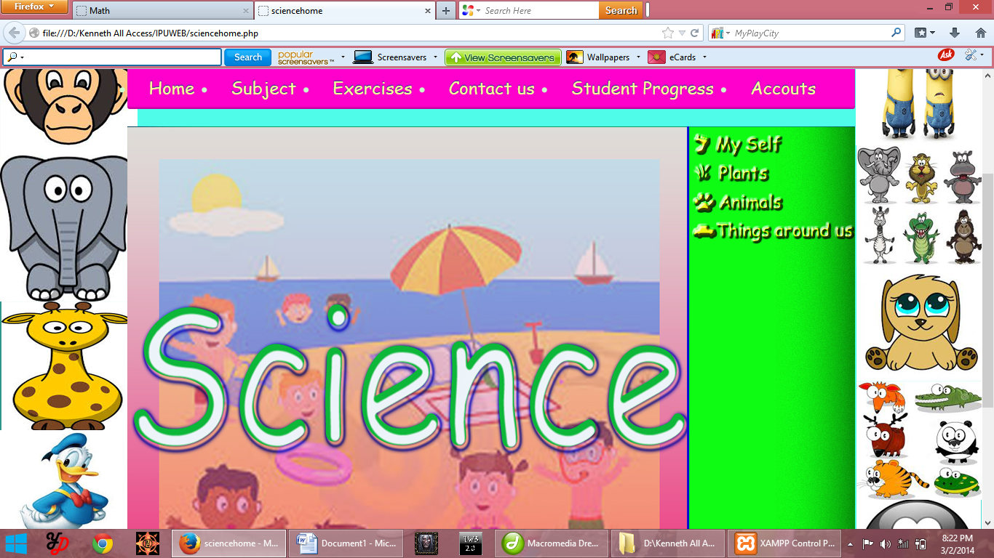

<HTML>

<HEAD>

<TITLE>sciencehome</TITLE>

<META HTTP-EQUIV="Content-Type" CONTENT="text/html; charset=iso-8859-1">

<style title="cssmenu">

import url(http://fonts.googleapis.com/css?family=Lato:300,400,700);

@charset 'UTF-8';

/* Base Styles */

#cssmenu > ul,

#cssmenu > ul li,

#cssmenu > ul ul {

list-style: none;

margin: 0;

padding: 0;

}

#cssmenu > ul {

position: relative;

z-index: 597;

float: left;

}

#cssmenu > ul li {

float: left;

min-height: 1px;

line-height: 1.3em;

vertical-align: middle;

padding: 10px;

}

#cssmenu > ul li.hover,

#cssmenu > ul li:hover {

z-index: 599;

cursor: default;

}

#cssmenu > ul ul {

visibility: hidden;

position: absolute;

top: 100%;

left: 0;

z-index: 598;

}

#cssmenu > ul ul li {

float: none;

}

#cssmenu > ul li:hover > ul {

visibility: visible;

}

/* Align last drop down RTL */

/* Theme Styles */

#cssmenu > ul a:link {

text-decoration: none;

}

#cssmenu > ul a:active {

color:#FFFF99;

}

#cssmenu li {

padding: 0;

color:#CCFFCC;

}

#cssmenu {

font-family:"comic sans ms",bold;

color:#0000FF;

width:auto;

-webkit-border-radius: 3px;

-moz-border-radius: 3px;

-ms-border-radius: 3px;

-o-border-radius: 3px;

border-radius: 3px;

background:#FF00CC;

font-size: 20px;

-moz-box-shadow: inset 0 2px 2px rgba(255, 255, 255, 0.3);

-webkit-box-shadow: inset 0 2px 2px rgba(255, 255, 255, 0.3);

box-shadow: inset 0 2px 2px rgba(255, 255, 255, 0.3);

}

#cssmenu > ul {

padding: 0 5px;

-moz-box-shadow: inset 0 -2px 2px rgba(0, 0, 0, 0.3);

-webkit-box-shadow: inset 0 -2px 2px rgba(0, 0, 0, 0.3);

box-shadow: inset 0 -2px 2px rgba(0, 0, 0, 0.3);

-webkit-border-radius: 3px;

-moz-border-radius: 3px;

-ms-border-radius: 3px;

-o-border-radius: 3px;

border-radius: 3px;

display: block;

float: none;

zoom: 1;

font-size:24px;

}

#cssmenu > ul:before {

content: '';

display: block;

}

#cssmenu > ul:after {

content: '';

display: table;

clear: both;

}

#cssmenu > ul > li {

padding: 8px 5px;

}

#cssmenu > ul > li > a,

#cssmenu > ul > li > a:link,

#cssmenu > ul > li > a:visited {

text-shadow: 0 -1px 1px #004881;

color:#FFFF99;

padding: 7px 20px;

display: block;

-webkit-border-radius: 3px;

-moz-border-radius: 3px;

-ms-border-radius: 3px;

-o-border-radius: 3px;

border-radius: 3px;

}

#cssmenu > ul > li > a:hover,

#cssmenu > ul > li:hover > a {

background-color: #0082e7;

}

#cssmenu li li a {

color:#0000FF;

font-size: 18px;

}

#cssmenu li li a:hover {

color:#FF00FF;

border-color: #5c5c5c;

}

#cssmenu ul ul {

margin: 0 10px;

padding: 0 10px;

float: none;

background:#00CC00;

border: 2px solid #1b9bff;

border-top: none;

right: 0;

left: 0;

-webkit-border-radius: 0 0 3px 3px;

-moz-border-radius: 0 0 3px 3px;

-ms-border-radius: 0 0 3px 3px;

-o-border-radius: 0 0 3px 3px;

border-radius: 0 0 3px 3px;

-moz-box-shadow: 0 2px 3px rgba(0, 0, 0, 0.2);

-webkit-box-shadow: 0 2px 3px rgba(0, 0, 0, 0.2);

box-shadow: 0 2px 3px rgba(0, 0, 0, 0.2);

}

#cssmenu ul > li > ul > li {

margin: 0 10px 0 0;

position: relative;

padding: 0;

float: left;

}

#cssmenu ul > li > ul > li > a {

padding: 10px 20px 10px 10px;

display: block;

}

#cssmenu ul > li > ul > li.has-sub > a:before {

content: '';

position: absolute;

top: 18px;

right: 6px;

border: 5px solid transparent;

border-top: 5px solid #8b8b8b;

}

#cssmenu ul > li > ul > li.has-sub > a:hover:before {

border-top: 5px solid #5c5c5c;

}

#cssmenu ul ul ul {

width: 200px;

top: 100%;

border: 2px solid #1b9bff;

}

#cssmenu ul ul ul li {

float: none;

}

</style>

</HEAD>

<center><BODY background="back copy.jpg" LEFTMARGIN=0 TOPMARGIN=0 MARGINWIDTH=0 MARGINHEIGHT=0>

<div align="center"><font color="#FF00FF" ><span id="spanDate"></span></font></div>

<script type="text/javascript">

var months = ['January','February','March','April','May','June','July',

'August','September','October','November','December'];

var tomorrow = new Date();

tomorrow.setTime(tomorrow.getTime() + (1000*3600*24));

document.getElementById("spanDate").innerHTML = months[tomorrow.getMonth()] + " " + tomorrow.getDate()+ ", " + tomorrow.getFullYear();

</script>

<!-- ImageReady Slices (sciencehome.psd) -->

<TABLE WIDTH=1000 BORDER=0 CELLPADDING=0 CELLSPACING=0>

<TR>

<TD COLSPAN=4>

<IMG SRC="images/sciencehome_01.jpg" WIDTH=1000 HEIGHT=178 ALT=""></TD>

</TR>

<TR>

<TD COLSPAN=4>

<div id='cssmenu'>

<ul>

<li class='active'><a href='homewelcome.php'><span>Home</span></a></li>

<li class='has-sub'><a href='subjects.php'><span>Subject</span></a>

<ul>

<li class='last'><a href='Math.php'><span>Math</span></a></li>

<li class='last'><a href='English.php'><span>English</span></a></li>

<li class='last'><a href='sciencehome.php'><span>Science</span></a></li>

</ul>

</li>

<li class="has-sub"><a href='#'><span>Exercises</span></a>

<ul>

<li class='last'><a href='#'><span>Math Exercises</span></a></li>

<li class='last'><a href='#'><span>English Exercises</span></a></li>

<li class='last'><a href='#'><span>Science Exercises</span></a></li>

</ul>

</li>

<li class='last'><a href='#'><span>Contact us</span></a></li>

<li class='last'><a href='#'><span>Student Progress</span></a></li>

<li class='last'><a href='#'><span>Accouts</span></a></li>

</ul>

</div>

<IMG SRC="images/sciencehome_02.jpg" WIDTH=1000 HEIGHT=18 ALT=""></TD>

</TR>

<TR>

<TD COLSPAN=2>

<IMG SRC="images/sciencehome_03.jpg" WIDTH=787 HEIGHT=27 ALT=""></TD>

<TD>

<a href="parstofbody.php"><IMG SRC="images/sciencehome_04.jpg" ALT="" WIDTH=119 HEIGHT=27 border="0"></a></TD>

<TD ROWSPAN=3>

<IMG SRC="images/sciencehome_05.jpg" WIDTH=94 HEIGHT=105 ALT=""></TD>

</TR>

<TR>

<TD ROWSPAN=4>

<IMG SRC="images/sciencehome_06.jpg" WIDTH=774 HEIGHT=777 ALT=""></TD>

<TD COLSPAN=2>

<a href="Plants-unit2.php"><IMG SRC="images/sciencehome_07.jpg" ALT="" WIDTH=132 HEIGHT=44 border="0"></a></TD>

</TR>

<TR>

<TD COLSPAN=2>

<a href="Unit3animals.php"><IMG SRC="images/sciencehome_08.jpg" ALT="" WIDTH=132 HEIGHT=34 border="0"></a></TD>

</TR>

<TR>

<TD COLSPAN=3>

<a href="Unit4thingsaroundus.php"><IMG SRC="images/sciencehome_09.jpg" ALT="" WIDTH=226 HEIGHT=54 border="0"></a></TD>

</TR>

<TR>

<TD COLSPAN=3>

<IMG SRC="images/sciencehome_10.jpg" WIDTH=226 HEIGHT=645 ALT=""></TD>

</TR>

<TR>

<TD>

<IMG SRC="images/spacer.gif" WIDTH=774 HEIGHT=1 ALT=""></TD>

<TD>

<IMG SRC="images/spacer.gif" WIDTH=13 HEIGHT=1 ALT=""></TD>

<TD>

<IMG SRC="images/spacer.gif" WIDTH=119 HEIGHT=1 ALT=""></TD>

<TD>

<IMG SRC="images/spacer.gif" WIDTH=94 HEIGHT=1 ALT=""></TD>

</TR>

</TABLE>

<!-- End ImageReady Slices -->

</BODY></center>

</HTML>

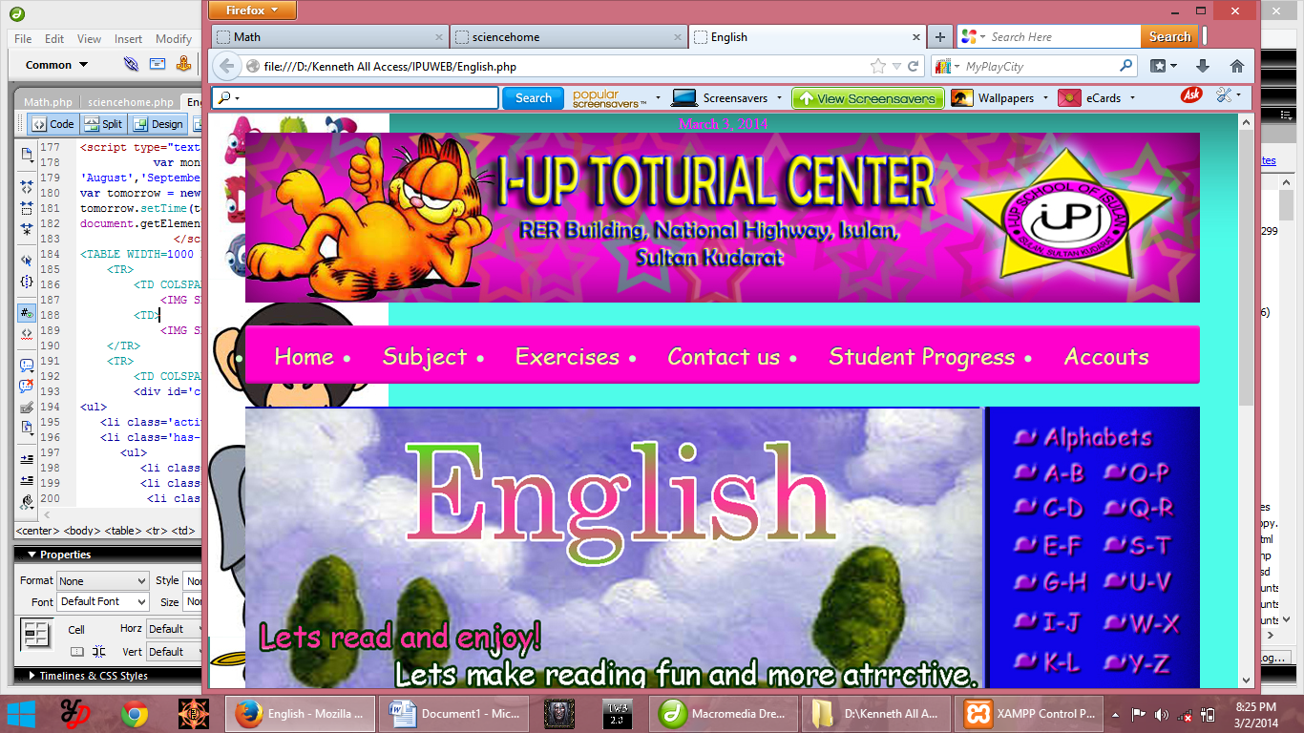

<HTML>

<HEAD>

<TITLE>English</TITLE>

<META HTTP-EQUIV="Content-Type" CONTENT="text/html; charset=iso-8859-1">

<style title="cssmenu">

import url(http://fonts.googleapis.com/css?family=Lato:300,400,700);

@charset 'UTF-8';

/* Base Styles */

#cssmenu > ul,

#cssmenu > ul li,

#cssmenu > ul ul {

list-style: none;

margin: 0;

padding: 0;

}

#cssmenu > ul {

position: relative;

z-index: 597;

float: left;

}

#cssmenu > ul li {

float: left;

min-height: 1px;

line-height: 1.3em;

vertical-align: middle;

padding: 10px;

}

#cssmenu > ul li.hover,

#cssmenu > ul li:hover {

z-index: 599;

cursor: default;

}

#cssmenu > ul ul {

visibility: hidden;

position: absolute;

top: 100%;

left: 0;

z-index: 598;

}

#cssmenu > ul ul li {

float: none;

}

#cssmenu > ul li:hover > ul {

visibility: visible;

}

/* Align last drop down RTL */

/* Theme Styles */

#cssmenu > ul a:link {

text-decoration: none;

}

#cssmenu > ul a:active {

color:#FFFF99;

}

#cssmenu li {

padding: 0;

color:#CCFFCC;

}

#cssmenu {

font-family:"comic sans ms",bold;

color:#0000FF;

width:auto;

-webkit-border-radius: 3px;

-moz-border-radius: 3px;

-ms-border-radius: 3px;

-o-border-radius: 3px;

border-radius: 3px;

background:#FF00CC;

font-size: 20px;

-moz-box-shadow: inset 0 2px 2px rgba(255, 255, 255, 0.3);

-webkit-box-shadow: inset 0 2px 2px rgba(255, 255, 255, 0.3);

box-shadow: inset 0 2px 2px rgba(255, 255, 255, 0.3);

}

#cssmenu > ul {

padding: 0 5px;

-moz-box-shadow: inset 0 -2px 2px rgba(0, 0, 0, 0.3);

-webkit-box-shadow: inset 0 -2px 2px rgba(0, 0, 0, 0.3);

box-shadow: inset 0 -2px 2px rgba(0, 0, 0, 0.3);

-webkit-border-radius: 3px;

-moz-border-radius: 3px;

-ms-border-radius: 3px;

-o-border-radius: 3px;

border-radius: 3px;

display: block;

float: none;

zoom: 1;

font-size:24px;

}

#cssmenu > ul:before {

content: '';

display: block;

}

#cssmenu > ul:after {

content: '';

display: table;

clear: both;

}

#cssmenu > ul > li {

padding: 8px 5px;

}

#cssmenu > ul > li > a,

#cssmenu > ul > li > a:link,

#cssmenu > ul > li > a:visited {

text-shadow: 0 -1px 1px #004881;

color:#FFFF99;

padding: 7px 20px;

display: block;

-webkit-border-radius: 3px;

-moz-border-radius: 3px;

-ms-border-radius: 3px;

-o-border-radius: 3px;

border-radius: 3px;

}

#cssmenu > ul > li > a:hover,

#cssmenu > ul > li:hover > a {

background-color: #0082e7;

}

#cssmenu li li a {

color:#0000FF;

font-size: 18px;

}

#cssmenu li li a:hover {

color:#FF00FF;

border-color: #5c5c5c;

}

#cssmenu ul ul {

margin: 0 10px;

padding: 0 10px;

float: none;

background:#00CC00;

border: 2px solid #1b9bff;

border-top: none;

right: 0;

left: 0;

-webkit-border-radius: 0 0 3px 3px;

-moz-border-radius: 0 0 3px 3px;

-ms-border-radius: 0 0 3px 3px;

-o-border-radius: 0 0 3px 3px;

border-radius: 0 0 3px 3px;

-moz-box-shadow: 0 2px 3px rgba(0, 0, 0, 0.2);

-webkit-box-shadow: 0 2px 3px rgba(0, 0, 0, 0.2);

box-shadow: 0 2px 3px rgba(0, 0, 0, 0.2);

}

#cssmenu ul > li > ul > li {

margin: 0 10px 0 0;

position: relative;

padding: 0;

float: left;

}

#cssmenu ul > li > ul > li > a {

padding: 10px 20px 10px 10px;

display: block;

}

#cssmenu ul > li > ul > li.has-sub > a:before {

content: '';

position: absolute;

top: 18px;

right: 6px;

border: 5px solid transparent;

border-top: 5px solid #8b8b8b;

}

#cssmenu ul > li > ul > li.has-sub > a:hover:before {

border-top: 5px solid #5c5c5c;

}

#cssmenu ul ul ul {

width: 200px;

top: 100%;

border: 2px solid #1b9bff;

}

#cssmenu ul ul ul li {

float: none;

}

</style>

</HEAD>

<center><BODY background="back copy.jpg" LEFTMARGIN=0 TOPMARGIN=0 MARGINWIDTH=0 MARGINHEIGHT=0>

<div align="center"><font color="#FF00FF" ><span id="spanDate"></span></font></div>

<script type="text/javascript">

var months = ['January','February','March','April','May','June','July',

'August','September','October','November','December'];

var tomorrow = new Date();

tomorrow.setTime(tomorrow.getTime() + (1000*3600*24));

document.getElementById("spanDate").innerHTML = months[tomorrow.getMonth()] + " " + tomorrow.getDate()+ ", " + tomorrow.getFullYear();

</script>

<TABLE WIDTH=1000 BORDER=0 CELLPADDING=0 CELLSPACING=0>

<TR>

<TD COLSPAN=12>

<IMG SRC="images/head.jpg" WIDTH=1000 HEIGHT=178 ALT=""></TD>

<TD>

<IMG SRC="images/spacer.gif" WIDTH=1 HEIGHT=178 ALT=""></TD>

</TR>

<TR>

<TD COLSPAN=12>

<div id='cssmenu'>

<ul>

<li class='active'><a href='homewelcome.php'><span>Home</span></a></li>

<li class='has-sub'><a href='subjects.php'><span>Subject</span></a>

<ul>

<li class='last'><a href='Math.php'><span>Math</span></a></li>

<li class='last'><a href='English.php'><span>English</span></a></li>

<li class='last'><a href='sciencehome.php'><span>Science</span></a></li>

</ul>

</li>

<li class="has-sub"><a href='#'><span>Exercises</span></a>

<ul>

<li class='last'><a href='#'><span>Math Exercises</span></a></li>

<li class='last'><a href='#'><span>English Exercises</span></a></li>

<li class='last'><a href='#'><span>Science Exercises</span></a></li>

</ul>

</li>

<li class='last'><a href='#'><span>Contact us</span></a></li>

<li class='last'><a href='#'><span>Student Progress</span></a></li>

<li class='last'><a href='#'><span>Accouts</span></a></li>

</ul>

</div>

<IMG SRC="images/English_02.jpg" WIDTH=1000 HEIGHT=20 ALT=""></TD>

<TD>

<IMG SRC="images/spacer.gif" WIDTH=1 HEIGHT=20 ALT=""></TD>

</TR>

<TR>

<TD COLSPAN=3 ROWSPAN=4>

<IMG SRC="images/English_03.jpg" WIDTH=809 HEIGHT=42 ALT=""></TD>

<TD COLSPAN=5>

<a href="alphabets.php"><IMG SRC="images/English_04.jpg" ALT="" WIDTH=142 HEIGHT=30 border="0"></a></TD>

<TD COLSPAN=4>

<IMG SRC="images/English_05.jpg" WIDTH=49 HEIGHT=30 ALT=""></TD>

<TD>

<IMG SRC="images/spacer.gif" WIDTH=1 HEIGHT=30 ALT=""></TD>

</TR>

<TR>

<TD COLSPAN=7 ROWSPAN=2>

<IMG SRC="images/English_06.jpg" WIDTH=169 HEIGHT=7 ALT=""></TD>

<TD COLSPAN=2>

<IMG SRC="images/English_07.jpg" WIDTH=22 HEIGHT=1 ALT=""></TD>

<TD>

<IMG SRC="images/spacer.gif" WIDTH=1 HEIGHT=1 ALT=""></TD>

</TR>

<TR>

<TD COLSPAN=2 ROWSPAN=13>

<IMG SRC="images/English_08.jpg" WIDTH=22 HEIGHT=160 ALT=""></TD>

<TD>

<IMG SRC="images/spacer.gif" WIDTH=1 HEIGHT=6 ALT=""></TD>

</TR>

<TR>

<TD COLSPAN=4>

<IMG SRC="images/English_09.jpg" WIDTH=90 HEIGHT=5 ALT=""></TD>

<TD COLSPAN=2 ROWSPAN=2>

<a href="op.php"><IMG SRC="images/English_10.jpg" ALT="" WIDTH=75 HEIGHT=26 border="0"></a></TD>

<TD ROWSPAN=12>

<IMG SRC="images/English_11.jpg" WIDTH=4 HEIGHT=154 ALT=""></TD>

<TD>

<IMG SRC="images/spacer.gif" WIDTH=1 HEIGHT=5 ALT=""></TD>

</TR>

<TR>

<TD COLSPAN=2 ROWSPAN=17>

<IMG SRC="images/English_12.jpg" WIDTH=804 HEIGHT=284 ALT=""></TD>

<TD COLSPAN=3>

<a href="ab.php"><IMG SRC="images/English_13.jpg" ALT="" WIDTH=77 HEIGHT=21 border="0"></a></TD>

<TD COLSPAN=2 ROWSPAN=15>

<IMG SRC="images/English_14.jpg" WIDTH=18 HEIGHT=235 ALT=""></TD>

<TD>

<IMG SRC="images/spacer.gif" WIDTH=1 HEIGHT=21 ALT=""></TD>

</TR>

<TR>

<TD COLSPAN=3>

<IMG SRC="images/English_15.jpg" WIDTH=77 HEIGHT=11 ALT=""></TD>

<TD COLSPAN=2>

<IMG SRC="images/English_16.jpg" WIDTH=75 HEIGHT=11 ALT=""></TD>

<TD>

<IMG SRC="images/spacer.gif" WIDTH=1 HEIGHT=11 ALT=""></TD>

</TR>

<TR>

<TD COLSPAN=2>

<a href="cd.php"><IMG SRC="images/English_17.jpg" ALT="" WIDTH=73 HEIGHT=25 border="0"></a></TD>

<TD ROWSPAN=4>

<IMG SRC="images/English_18.jpg" WIDTH=4 HEIGHT=43 ALT=""></TD>

<TD COLSPAN=2 ROWSPAN=2>

<a href="qr.php"><IMG SRC="images/English_19.jpg" ALT="" WIDTH=75 HEIGHT=31 border="0"></a></TD>

<TD>

<IMG SRC="images/spacer.gif" WIDTH=1 HEIGHT=25 ALT=""></TD>

</TR>

<TR>

<TD COLSPAN=2 ROWSPAN=3>

<IMG SRC="images/English_20.jpg" WIDTH=73 HEIGHT=18 ALT=""></TD>

<TD>

<IMG SRC="images/spacer.gif" WIDTH=1 HEIGHT=6 ALT=""></TD>

</TR>

<TR>

<TD COLSPAN=2>

<IMG SRC="images/English_21.jpg" WIDTH=75 HEIGHT=8 ALT=""></TD>

<TD>

<IMG SRC="images/spacer.gif" WIDTH=1 HEIGHT=8 ALT=""></TD>

</TR>

<TR>

<TD COLSPAN=2 ROWSPAN=2>

<a href="st.php"><IMG SRC="images/English_22.jpg" ALT="" WIDTH=75 HEIGHT=27 border="0"></a></TD>

<TD>

<IMG SRC="images/spacer.gif" WIDTH=1 HEIGHT=4 ALT=""></TD>

</TR>

<TR>

<TD ROWSPAN=3>

<IMG SRC="images/English_23.jpg" WIDTH=5 HEIGHT=36 ALT=""></TD>

<TD COLSPAN=2>

<a href="ef.php"><IMG SRC="images/English_24.jpg" ALT="" WIDTH=72 HEIGHT=23 border="0"></a></TD>

<TD>

<IMG SRC="images/spacer.gif" WIDTH=1 HEIGHT=23 ALT=""></TD>

</TR>

<TR>

<TD COLSPAN=2 ROWSPAN=2>

<IMG SRC="images/English_25.jpg" WIDTH=72 HEIGHT=13 ALT=""></TD>

<TD COLSPAN=2>

<IMG SRC="images/English_26.jpg" WIDTH=75 HEIGHT=9 ALT=""></TD>

<TD>

<IMG SRC="images/spacer.gif" WIDTH=1 HEIGHT=9 ALT=""></TD>

</TR>

<TR>

<TD COLSPAN=2 ROWSPAN=2>

<a href="uv.php"><IMG SRC="images/English_27.jpg" ALT="" WIDTH=75 HEIGHT=30 border="0"></a></TD>

<TD>

<IMG SRC="images/spacer.gif" WIDTH=1 HEIGHT=4 ALT=""></TD>

</TR>

<TR>

<TD COLSPAN=3>

<a href="gh.php"><IMG SRC="images/English_28.jpg" ALT="" WIDTH=77 HEIGHT=26 border="0"></a></TD>

<TD>

<IMG SRC="images/spacer.gif" WIDTH=1 HEIGHT=26 ALT=""></TD>

</TR>

<TR>

<TD COLSPAN=3>

<IMG SRC="images/English_29.jpg" WIDTH=77 HEIGHT=12 ALT=""></TD>

<TD COLSPAN=2>

<IMG SRC="images/English_30.jpg" WIDTH=75 HEIGHT=12 ALT=""></TD>

<TD>

<IMG SRC="images/spacer.gif" WIDTH=1 HEIGHT=12 ALT=""></TD>

</TR>

<TR>

<TD COLSPAN=3>

<a href="ij.php"><IMG SRC="images/English_31.jpg" ALT="" WIDTH=77 HEIGHT=26 border="0"></a></TD>

<TD COLSPAN=4>

<a href="wx.php"><IMG SRC="images/English_32.jpg" ALT="" WIDTH=84 HEIGHT=26 border="0"></a></TD>

<TD ROWSPAN=6>

<IMG SRC="images/English_33.jpg" WIDTH=17 HEIGHT=135 ALT=""></TD>

<TD>

<IMG SRC="images/spacer.gif" WIDTH=1 HEIGHT=26 ALT=""></TD>

</TR>

<TR>

<TD COLSPAN=3>

<IMG SRC="images/English_34.jpg" WIDTH=77 HEIGHT=17 ALT=""></TD>

<TD COLSPAN=4>

<IMG SRC="images/English_35.jpg" WIDTH=84 HEIGHT=17 ALT=""></TD>

<TD>

<IMG SRC="images/spacer.gif" WIDTH=1 HEIGHT=17 ALT=""></TD>

</TR>

<TR>

<TD COLSPAN=3>

<a href="kl.php"><IMG SRC="images/English_36.jpg" ALT="" WIDTH=77 HEIGHT=26 border="0"></a></TD>

<TD COLSPAN=4>

<a href="yz.php"><IMG SRC="images/English_37.jpg" ALT="" WIDTH=84 HEIGHT=26 border="0"></a></TD>

<TD>

<IMG SRC="images/spacer.gif" WIDTH=1 HEIGHT=26 ALT=""></TD>

</TR>

<TR>

<TD COLSPAN=3>

<IMG SRC="images/English_38.jpg" WIDTH=77 HEIGHT=17 ALT=""></TD>

<TD COLSPAN=4 ROWSPAN=3>

<IMG SRC="images/English_39.jpg" WIDTH=84 HEIGHT=66 ALT=""></TD>

<TD>

<IMG SRC="images/spacer.gif" WIDTH=1 HEIGHT=17 ALT=""></TD>

</TR>

<TR>

<TD COLSPAN=4>

<a href="mn.php"><IMG SRC="images/English_40.jpg" ALT="" WIDTH=86 HEIGHT=29 border="0"></a></TD>

<TD ROWSPAN=2>

<IMG SRC="images/English_41.jpg" WIDTH=9 HEIGHT=49 ALT=""></TD>

<TD>

<IMG SRC="images/spacer.gif" WIDTH=1 HEIGHT=29 ALT=""></TD>

</TR>

<TR>

<TD COLSPAN=4>

<IMG SRC="images/English_42.jpg" WIDTH=86 HEIGHT=20 ALT=""></TD>

<TD>

<IMG SRC="images/spacer.gif" WIDTH=1 HEIGHT=20 ALT=""></TD>

</TR>

<TR>

<TD>

<IMG SRC="images/English_43.jpg" WIDTH=784 HEIGHT=476 ALT=""></TD>

<TD COLSPAN=11>

<IMG SRC="images/English_44.jpg" WIDTH=216 HEIGHT=476 ALT=""></TD>

<TD>

<IMG SRC="images/spacer.gif" WIDTH=1 HEIGHT=476 ALT=""></TD>

</TR>

<TR>

<TD>

<IMG SRC="images/spacer.gif" WIDTH=784 HEIGHT=1 ALT=""></TD>

<TD>

<IMG SRC="images/spacer.gif" WIDTH=20 HEIGHT=1 ALT=""></TD>

<TD>

<IMG SRC="images/spacer.gif" WIDTH=5 HEIGHT=1 ALT=""></TD>

<TD>

<IMG SRC="images/spacer.gif" WIDTH=68 HEIGHT=1 ALT=""></TD>

<TD>

<IMG SRC="images/spacer.gif" WIDTH=4 HEIGHT=1 ALT=""></TD>

<TD>

<IMG SRC="images/spacer.gif" WIDTH=9 HEIGHT=1 ALT=""></TD>

<TD>

<IMG SRC="images/spacer.gif" WIDTH=9 HEIGHT=1 ALT=""></TD>

<TD>

<IMG SRC="images/spacer.gif" WIDTH=52 HEIGHT=1 ALT=""></TD>

<TD>

<IMG SRC="images/spacer.gif" WIDTH=23 HEIGHT=1 ALT=""></TD>

<TD>

<IMG SRC="images/spacer.gif" WIDTH=4 HEIGHT=1 ALT=""></TD>

<TD>

<IMG SRC="images/spacer.gif" WIDTH=5 HEIGHT=1 ALT=""></TD>

<TD>

<IMG SRC="images/spacer.gif" WIDTH=17 HEIGHT=1 ALT=""></TD>

<TD></TD>

</TR>

</TABLE>

<!-- End ImageReady Slices -->

</BODY></center>

</HTML>

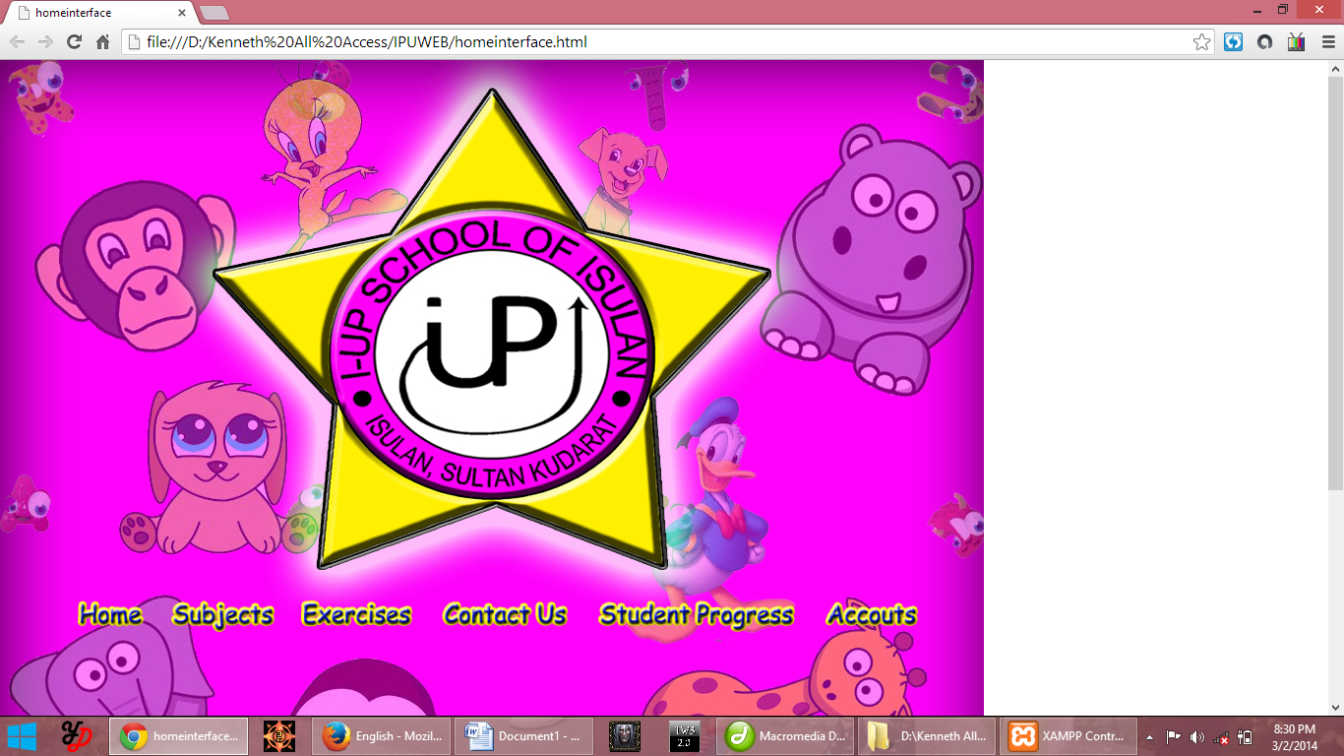

<HTML>

<HEAD>

<TITLE>homeinterface</TITLE>

<META HTTP-EQUIV="Content-Type" CONTENT="text/html; charset=iso-8859-1">

<style title="cssmenu">

import url(http://fonts.googleapis.com/css?family=Lato:300,400,700);

@charset 'UTF-8';

/* Base Styles */

#cssmenu > ul,

#cssmenu > ul li,

#cssmenu > ul ul {

list-style: none;

margin: 0;

padding: 0;

}

#cssmenu > ul {

position: relative;

z-index: 597;

float: left;

}

#cssmenu > ul li {

float: left;

min-height: 1px;

line-height: 1.3em;

vertical-align: middle;

padding: 10px;

}

#cssmenu > ul li.hover,

#cssmenu > ul li:hover {

z-index: 599;

cursor: default;

}

#cssmenu > ul ul {

visibility: hidden;

position: absolute;

top: 100%;

left: 0;

z-index: 598;

}

#cssmenu > ul ul li {

float: none;

}

#cssmenu > ul li:hover > ul {

visibility: visible;

}

/* Align last drop down RTL */

/* Theme Styles */

#cssmenu > ul a:link {

text-decoration: none;

}

#cssmenu > ul a:active {

color:#FFFF99;

}

#cssmenu li {

padding: 0;

color:#CCFFCC;

}

#cssmenu {

font-family:"comic sans ms",bold;

color:#0000FF;

width:auto;

-webkit-border-radius: 3px;

-moz-border-radius: 3px;

-ms-border-radius: 3px;

-o-border-radius: 3px;

border-radius: 3px;

background:#FF00CC;

font-size: 20px;

-moz-box-shadow: inset 0 2px 2px rgba(255, 255, 255, 0.3);

-webkit-box-shadow: inset 0 2px 2px rgba(255, 255, 255, 0.3);

box-shadow: inset 0 2px 2px rgba(255, 255, 255, 0.3);

}

#cssmenu > ul {

padding: 0 5px;

-moz-box-shadow: inset 0 -2px 2px rgba(0, 0, 0, 0.3);

-webkit-box-shadow: inset 0 -2px 2px rgba(0, 0, 0, 0.3);

box-shadow: inset 0 -2px 2px rgba(0, 0, 0, 0.3);

-webkit-border-radius: 3px;

-moz-border-radius: 3px;

-ms-border-radius: 3px;

-o-border-radius: 3px;

border-radius: 3px;

display: block;

float: none;

zoom: 1;

font-size:24px;

}

#cssmenu > ul:before {

content: '';

display: block;

}

#cssmenu > ul:after {

content: '';

display: table;

clear: both;

}

#cssmenu > ul > li {

padding: 8px 5px;

}

#cssmenu > ul > li > a,

#cssmenu > ul > li > a:link,

#cssmenu > ul > li > a:visited {

text-shadow: 0 -1px 1px #004881;

color:#FFFF99;

padding: 7px 20px;

display: block;

-webkit-border-radius: 3px;

-moz-border-radius: 3px;

-ms-border-radius: 3px;

-o-border-radius: 3px;

border-radius: 3px;

}

#cssmenu > ul > li > a:hover,

#cssmenu > ul > li:hover > a {

background-color: #0082e7;

}

#cssmenu li li a {

color:#0000FF;

font-size: 18px;

}

#cssmenu li li a:hover {

color:#FF00FF;

border-color: #5c5c5c;

}

#cssmenu ul ul {

margin: 0 10px;

padding: 0 10px;

float: none;

background:#00CC00;

border: 2px solid #1b9bff;

border-top: none;

right: 0;

left: 0;

-webkit-border-radius: 0 0 3px 3px;

-moz-border-radius: 0 0 3px 3px;

-ms-border-radius: 0 0 3px 3px;

-o-border-radius: 0 0 3px 3px;

border-radius: 0 0 3px 3px;

-moz-box-shadow: 0 2px 3px rgba(0, 0, 0, 0.2);

-webkit-box-shadow: 0 2px 3px rgba(0, 0, 0, 0.2);

box-shadow: 0 2px 3px rgba(0, 0, 0, 0.2);

}

#cssmenu ul > li > ul > li {

margin: 0 10px 0 0;

position: relative;

padding: 0;

float: left;

}

#cssmenu ul > li > ul > li > a {

padding: 10px 20px 10px 10px;

display: block;

}

#cssmenu ul > li > ul > li.has-sub > a:before {

content: '';

position: absolute;

top: 18px;

right: 6px;

border: 5px solid transparent;

border-top: 5px solid #8b8b8b;

}

#cssmenu ul > li > ul > li.has-sub > a:hover:before {

border-top: 5px solid #5c5c5c;

}

#cssmenu ul ul ul {

width: 200px;

top: 100%;

border: 2px solid #1b9bff;

}

#cssmenu ul ul ul li {

float: none;

}

</style>

</HEAD>

<BODY BGCOLOR=#FFFFFF LEFTMARGIN=0 TOPMARGIN=0 MARGINWIDTH=0 MARGINHEIGHT=0>

<!-- ImageReady Slices (homeinterface.psd) -->

<TABLE WIDTH=1000 BORDER=0 CELLPADDING=0 CELLSPACING=0>

<TR>

<TD COLSPAN=10>

<IMG SRC="images/homeinterface_01.jpg" WIDTH=1000 HEIGHT=33 ALT=""></TD>

</TR>

<TR>

<TD COLSPAN=3 ROWSPAN=2>

<IMG SRC="images/homeinterface_02.jpg" WIDTH=238 HEIGHT=514 ALT=""></TD>

<TD COLSPAN=4>

<IMG SRC="images/homeinterface_03.jpg" WIDTH=512 HEIGHT=492 ALT=""></TD>

<TD COLSPAN=3 ROWSPAN=2>

<IMG SRC="images/homeinterface_04.jpg" WIDTH=250 HEIGHT=514 ALT=""></TD>

</TR>

<TR>

<TD COLSPAN=4>

<IMG SRC="images/homeinterface_05.jpg" WIDTH=512 HEIGHT=22 ALT=""></TD>

</TR>

<TR>

<TD ROWSPAN=2>

<IMG SRC="images/homeinterface_06.jpg" WIDTH=61 HEIGHT=453 ALT=""></TD>

<TD>

<a href="homeinterface.php"><IMG SRC="images/homeinterface_07.jpg" ALT="" WIDTH=102 HEIGHT=44 border="0"></a></TD>

<TD COLSPAN=2>

<a href="subjects.php"><IMG SRC="images/homeinterface_08.jpg" ALT="" WIDTH=129 HEIGHT=44 border="0"></a></TD>

<TD>

<a href="#"><IMG SRC="images/homeinterface_09.jpg" ALT="" WIDTH=137 HEIGHT=44 border="0"></a></TD>

<TD>

<a href="#"><IMG SRC="images/homeinterface_10.jpg" ALT="" WIDTH=156 HEIGHT=44 border="0"></a></TD>

<TD COLSPAN=2>

<a href="#"><IMG SRC="images/homeinterface_11.jpg" ALT="" WIDTH=232 HEIGHT=44 border="0"></a></TD>

<TD>

<a href="#"><IMG SRC="images/homeinterface_12.jpg" ALT="" WIDTH=126 HEIGHT=44 border="0"></a></TD>

<TD ROWSPAN=2>

<IMG SRC="images/homeinterface_13.jpg" WIDTH=57 HEIGHT=453 ALT=""></TD>

</TR>

<TR>

<TD COLSPAN=8>

<IMG SRC="images/homeinterface_14.jpg" WIDTH=882 HEIGHT=409 ALT=""></TD>

</TR>

<TR>

<TD>

<IMG SRC="images/spacer.gif" WIDTH=61 HEIGHT=1 ALT=""></TD>

<TD>

<IMG SRC="images/spacer.gif" WIDTH=102 HEIGHT=1 ALT=""></TD>

<TD>

<IMG SRC="images/spacer.gif" WIDTH=75 HEIGHT=1 ALT=""></TD>

<TD>

<IMG SRC="images/spacer.gif" WIDTH=54 HEIGHT=1 ALT=""></TD>

<TD>

<IMG SRC="images/spacer.gif" WIDTH=137 HEIGHT=1 ALT=""></TD>

<TD>

<IMG SRC="images/spacer.gif" WIDTH=156 HEIGHT=1 ALT=""></TD>

<TD>

<IMG SRC="images/spacer.gif" WIDTH=165 HEIGHT=1 ALT=""></TD>

<TD>

<IMG SRC="images/spacer.gif" WIDTH=67 HEIGHT=1 ALT=""></TD>

<TD>

<IMG SRC="images/spacer.gif" WIDTH=126 HEIGHT=1 ALT=""></TD>

<TD>

<IMG SRC="images/spacer.gif" WIDTH=57 HEIGHT=1 ALT=""></TD>

</TR>

</TABLE>

<!-- End ImageReady Slices -->

</BODY>

</HTML>